AUTOMATED BARANGAY INFORMATION SYSTEM

An Undergraduate Capstone Project
Presented to
The Faculty of College of Technology
Iloilo State University of Fisheries Science and Technology - Dumangas Campus
Dumangas Iloilo

In Partial Fulfillment
Of the Requirements for the Degree
Bachelor of Science in Information Technology

by:
Jenny G. Saude
Emilyn D. Diaz
Shien Pineda
Joedilyn Vinson
Rachel Beth Lasquite
Angel Avelino

May 15 2025

CHAPTER I
INTRODUCTION
Requests, thereby reducing paperwork and minimizing errors
By promoting transparency and accountability, ABIS encourages community engagement and participation in local governance.
Ultimately, the implementation of ABIS aligns with the digital transformation goals in public The Automated Barangay Information System (ABIS) addresses the challenges faced by barangay in the Philippines, which are essential units of local governance. Many barangays struggle with outdated manual processes, leading to inefficiencies in information management and service delivery. ABIS aims to modernize these operations by automating administrative tasks, enhancing data management, and improving access to service for both officials and residents.

The system focuses on efficient data collection, management of community programs, and automation of service. Administration, enabling barangays to better serve their communities and respond to their evolving needs. This innovative system represents a significant advancement in local governance, fostering efficiency, transparency, and active community involvement.
Project Context
Developed in response to the pressing need for efficient governance at the barangay level in the Philippines. Barangays as the smallest administrative units, play a vital role in local governance and community development. However, many face challenges such as outdated manual processes, limited access to information, and inefficient service delivery.
In this context, ABIS aims to leverage technology to streamline administrative functions, enhance data management, and improve communication between barangay officials and residents. By automating processes such as data collection, record-keeping, and service requests, the system seeks to reduce administrative burdens and errors while promoting transparency and accountability.
The project aligns with national initiatives for digital transformation in public administration, aiming to empower barangays to better serve their constituents. By implementing ABIS, barangays can expect improved operational efficiency, increased community engagement, and a more responsive governance framework that meets the evolving needs of their communities.
Officials:In performing their duties more efficiently by replacing the manual processing of barangay records and transactions. Traditionally, barangay officials rely on handwritten logs, paper files, and manual documentation to record resident information, issue certificates, and prepare reports.
Residents:Is designed not only to support barangay officials but also to provide better and faster services to residents. In the traditional manual system, residents often experience delays and inconvenience when requesting documents such as barangay clearance, certificate of residency, or certificate of indigency.
Reports:Provides various reports that help barangay officials monitor, analyze, and manage barangay operations more effectively. These reports replace the traditional manual documentation, making data retrieval and presentation faster, more accurate, and easier to update.
Services:Provides several services for manual processing. It helps store and update resident records digitally, making it easier to manage personal information. It automates the issuance of barangay clearances and other certifications. The system records and monitors business permits and renewals efficiently. It keeps digital records of complaints and incidents esthete blotter management feature. Financial tracking becomes easier as it automates income, expenses, and budget reports.
Purpose and Description
To streamline, organize, and digitize the management of barangay data and operations. It aims to improve efficiency, accuracy, and accessibility of information for local governance and community services.
Is a computerized platform that consolidates various barangay records and processes. It typically includes modules for managing resident information, barangay officials, barangay projects and programs, financial transactions, health and social services, and other community-related data. The system facilitates quick data retrieval, reporting, and decision-making, thereby enhancing transparency and accountability in barangay governance. It often features user-friendly interfaces and secure access controls to ensure data integrity and privacy.
Objective of Study
To develop an Automated Barangay Information System that will streamline the management of barangay data, improve service delivery, and enhance governance at the barangay level.
- To develop an Automated Barangay Information System that streamlines the management, storage, and retrieval of residents’ records and barangay transactions.

- To enhance the efficiency and accuracy of barangay operations by automating manual processes such as record keeping, certification issuance, and reporting.

- To improve accessibility and transparency of barangay information for both officials and residents through a centralized and user-friendly system.

- To strengthen data security and integrity by implementing controlled access and digital record management features.

- To support barangay officials in decision-making and governance by providing timely and accurate data reports and analytic .

Conceptual Framework

The system generates reports on community demo graphics service usage, and resource allocation aiding in decision- making.
OUTPUT

Information from residents, including personal details ,health records, and service request is gathered trough online forms
INPUT

The system process input data to maintain an organized database allowing for easy retrieval and updates.

PROCESS

Feedback/Evaluation

Figure 1. Conceptual Framework of the application
Figure 1 shows the Conceptual Framework of the study. The input, process and output were considered.
The input includes barangay records, health records, and census data. The process involves searching, managing, and generating reports. The system processes resident data input through a Progressive Web Application, utilizing an English-Tagalog chatbot for inquiries and geolocation technology for disaster monitoring. Outputs include streamlined service delivery, improved user experience, and effective community engagement. This system will be evaluated in terms of product quality and quality in use.
Significance of the Study
This study aimed to provide crucial information about the Automated Barangay Information System (ABIS) — a digital platform designed to automate and simplify the management of barangay records, resident information, and local transactions. The system ensures accurate, organized, and easily accessible data that supports efficient governance and faster public service delivery. The results of this study will be a great benefit to the following:
- Barangay Officials and Staff. This system provides a powerful tool that improves the accuracy, efficiency, and speed of managing barangay records and transactions. By automating manual processes such as resident profiling, certificate issuance, and report generation, officials can perform their administrative duties more effectively and focus on decision-making and community programs.
- Residents. The system offers convenience by allowing residents to process documents such as certificates, permits, and clearances more quickly. It reduces waiting time and ensures transparency in barangay services, fostering trust between residents and barangay officials.
- Local Government Units (LGUs).The system enhances coordination between the barangay and higher-level government offices by providing standardized, accurate, and up-to-date data. It supports the efficient transmission of reports, statistics, and documents necessary for policy planning and resource allocation.
- Community. Through efficient record management and transparent service delivery, the system promotes accountability and good governance. It contributes to better community relations, improved data-driven decision-making, and a more responsive barangay administration.
- Academic and Research Community. The study serves as a reference for future researchers and developers interested in local government automation. It provides valuable insights into how information systems can be applied to improve administrative efficiency and public service in grassroots governance.
- Policy Makers and Government Institutions. The Automated Barangay Information System demonstrates how digital transformation can enhance local governance. It supports initiatives promoting e-governance, transparency, and citizen participation, serving as a model for other barangays or municipalities seeking modernization.

Scope and Limitations of the Study
A systems enable better record-keeping and retrieval, minimizing redundancy and improving accuracy in data handling. And There may be reluctance among barangay a
officials and constituents to adopt new technologies, impacting system utilization.
Barangay. The smallest administrative division in the Philippines, similar to a village, district, or ward. It serves as the primary planning and implementing unit of government policies, programs, and activities.
Automated System. A computerized system designed to perform tasks with minimal human intervention. In the context of a barangay, it refers to using software and databases to handle operations like record-keeping, reporting, and communication.
Barangay Clearance. An official document issued by the barangay certifying that a person is a resident and has no pending obligations or cases. An automated system can generate and print this quickly.
Digital Records. Electronic versions of paper documents stored in the system, such as certificates, permits, and resident applications
Image. An image is a picture or other representation of a person or thing, or it can be someone's public perception, like a rock star
who tries to change his image by dressing like a professor and learning to play chess (Vocabulary, 24 Oct. 2023)
PYTHON. An interpreted, object-oriented, high-level programming language with dynamic semantics. Its high-level built in data structures, combined with dynamic typing and dynamic binding, make it very attractive for Rapid Application Development, as well as for use as a scripting or glue language to connect existing components together. (python,2022)
As used in this study, refers to the programming language tool used to develop the application.

SQL. It stands for Structured Query Language. It is a standard language for accessing databases and has been an international standard (ISO) since 1987.( W3Schools, 1999-2023)

As used in this study, refers to the database management system tool used to develop the application.

DJANGO. It is a high-level Python web framework that enables rapid development of secure and maintainable websites. Built by experienced developers, Django takes care of much of the hassle of web development, so you can focus on writing your app without needing to reinvent the wheel. It is free and open source, has a thriving and active community, great documentation, and many options for free and paid-for support. ( MDN contributors, 2023,)
As used in this study, refers to an open source web framework tool used to develop the application.

Dumangas. The municipality has a land area of 128.70 square kilometers or 49.69 square miles which constitutes 2.58% of Iloilo's total area. (Name of Author, 2020)
In this study, it refers to the area where the study will be implemented.
In this study, it refers to where the study will be implemented.
Web App. A web application is software that runs in your web browser. Businesses have to exchange information and deliver services remotely. They use web applications to connect with customers conveniently and securely. (amazon, 2023)

In this study, it refers to what program or software the study will implement.

Locator. one that locates something (such as a mining claim or the course of a road. (Merriam Webster, 2023)

Agile software development refers to a group of software development methodologies based on iterative development,
where requirements and solutions evolve through collaboration between self-organizing cross-functional teams.(Kate Brush, November 2022)

Definition of Terms
A computerized system designed to store, manage, and process barangay records and transactions efficiently. It automates manual operations such as resident profiling, document issuance, and report generation to improve accuracy, accessibility, and service delivery.

Database Management System (DBMS)
Software that allows users to create, manage, and manipulate data in a structured format. In the ABIS, it is used to store and organize resident profiles, permits, and other barangay records.

Resident Profiling
The process of collecting and maintaining detailed demographic information of individuals residing within the barangay for administrative and planning purposes.

Data Validation
The process of ensuring that the information entered into the system is accurate, complete, and consistent with predefined standards.

User Authentication
A security mechanism that verifies the identity of users before granting access to the system, typically through usernames, passwords, or biometric credentials.

Access Control
A security feature that restricts system access to authorized personnel only, based on user roles or privileges.

Data Encryption
The process of converting sensitive information into a secure format to prevent unauthorized access or disclosure.

Barangay Clearance
An official document issued by the barangay certifying that an individual is a resident of good standing and has no pending case or obligation within the community. The ABIS automates the issuance and record keeping of this document.

Incident Report
A formal record of events or disturbances within the barangay, such as disputes or violations, which are digitally logged and monitored in the system.

Dashboard
A visual interface that displays real-time data, summaries, and reports to assist barangay officials in decision-making and monitoring community activities.

Technical terms
A database is an electronically stored, systematic collection of data that can include words, numbers, images, videos, and other types of files.
(https://www.geeksforgeeks.org/what-is-database/)
In this study, it refers to the database that serves as the central repository of barangay records, including resident profiles, certificates, business permits, incident reports, and financial transactions managed within the system.

Information System
An information system is an organized system for the collection, organization, storage, and communication of information.
(https://www.britannica.com/topic/information-system)
In this study, it refers to the computerized system designed to automate various barangay processes such as resident management, certification, and reporting to enhance efficiency and accuracy in local governance.

Programming Language
A programming language is a formal language comprising a set of instructions that produce various kinds of output, allowing humans to communicate with computers.
(Cervantes & Andrés, 2025)
In this study, it refers to the programming languages such as PHP, HTML, CSS, and MySQL used to develop and implement the core modules of the Automated Barangay Information System, enabling interaction between users and the system.
JANICA NOTES:
- Instead of PHP AND HTML: programmer used REACT JS, CSS as FRONTEND
- MongoDB as BACKEND

Prototype / Prototyping
A prototype is an incomplete version of a physical or digital product created to test and demonstrate its key functions before the final version is developed.

(https://airfocus.com/glossary/what-is-a-prototype/)

In this study, it refers to the initial working version of the Automated Barangay Information System that demonstrates its essential features, including data entry, certificate generation, and automated reporting for barangay officials.

Non- Technical Terms
Barangay Clearance. An official document issued by the barangay that certifies a person is a resident of the barangay and has no pending obligations or complaints.
In this study, barangay clearance refers to one of the main certificates generated through the Automated Barangay Information System (ABIS), allowing faster processing and issuance of official documents to residents.

Resident Profile. A collection of personal information about an individual living within a barangay, including name, address, age, occupation, and household details.

In this study, resident profile refers to the digital record stored in the ABIS database, which can be easily retrieved or updated by authorized barangay officials.
Certificate Issuance. The process of preparing and releasing official barangay documents for various purposes, such as residency, indigency, or good moral character.
In this study, certificate issuance refers to the automated function of ABIS that allows barangay officials to generate and print certificates quickly and accurately without manual writing.

Blotter Record. A record of incidents, complaints, and disputes filed within the barangay.
In this study, blotter record refers to the digital log stored in ABIS that replaces the traditional handwritten blotter book, providing easier access, tracking, and report generation.

Business Permit.An official authorization granted by the
barangay that allows individuals or organizations to

conduct business within its jurisdiction.
In this study, business permit refers to the module within
ABIS that records and manages business applications,
renewals, and approvals.

Resident Information Management.The systematic organization and updating of resident data within the barangay.
In this study, resident information management refers to the ABIS feature that automates the collection, editing, .and retrieval of resident records for administrative use.

Acronym
Acronym Meaning
ABIS Automated Barangay Information System
DBMS Database Management System
HTML Hypertext Markup Language
CSS Cascading Style Sheets
PHP Hypertext Preprocessor
UI User Interface
UX User Experience
SQL Structured Query Language
LAN Local Area Network
PDF Portable Document Format
HTTP Hypertext Transfer Protocol
PC Personal Computer
GUI Graphical User Interface
CRUD Create, Read, Update, Delete
IT Information Technology
ICT Information and Communications Technology

CHAPTER II
Review of Related Literature
This chapter presents a review of literature and studies relevant to the development of an Automated Barangay Information System (ABIS). The reviewed works provide insights into the use of information systems, database management, and automation in improving local governance and community services.
Review of Foreign Local Literature
In the study of Dela Cruz et al. (2018) titled “Barangay Information System with Decision Support for Community-Based Programs,” the researchers developed a computerized system to manage household and resident records within the barangay. The system allowed barangay officials to efficiently generate reports, monitor demographic statistics, and plan community programs. The study concluded that automation minimizes human error, reduces redundancy, and enables faster data retrieval. This aligns with the current study’s goal to create a centralized barangay database capable of handling both administrative and security-related records.

Santos and Bautista (2020) in their research “eBarangay: An Integrated Barangay Management Information System” highlighted the importance of digitization in local governance. Their system provided modules for resident profiling, incident tracking, and certification requests. Results showed improved data accuracy, transparency, and workflow efficiency. In relation to the proposed study, the integration of a reporting module for wanted individuals can enhance real-time information sharing and strengthen Barangay-level crime monitoring.

Magboo (2016) conducted a study entitled “Missing Persons and Wanted Fugitives Information and Reporting System Using Face Recognition for Cross-Matching.” The research developed a system that used facial recognition technology to identify missing persons and fugitives through uploaded images. It also allowed the public to submit tips that could assist law enforcement. This study is closely related to the proposed system as it demonstrates how integrating biometric technologies into

barangay systems can improve law enforcement coordination and speed up the identification of wanted individuals.

Villanueva et al. (2021) in their study “Barangay Management Information System with GIS Integration” introduced the use of Geographic Information Systems (GIS) for mapping residents, facilities, and incident locations. The GIS integration helped barangay officials visualize data for decision-making in public safety, disaster response, and resource allocation. The study’s findings highlight the importance of integrating real-time and location-based technologies, which can also be applied to crime reporting systems within barangays.
Sharma and Gupta (2019), in their study titled “Community Information Systems for Local Governance: A Digital Approach,” discussed the importance of centralized data management in improving local administration. The system developed in their research supported resident registration, complaints tracking, and communication between officials and citizens. The study revealed that automation at the community level enhances data accessibility and

transparency—principles that support the development of an automated barangay information system for managing resident and incident records.
Thomas (2015) in “Combining Facial Recognition, Automatic License Plate Readers, and CCTV to Create an Interstate Identification System for Wanted Subjects” explored how multiple surveillance technologies can be integrated to track and identify persons of interest. The study emphasized the benefits of centralized monitoring systems in improving public safety and law enforcement efficiency. This research supports the inclusion of a facial recognition and reporting feature within the proposed barangay system to enhance its capability in detecting and reporting wanted individuals.
Review of Related Local Literature
Ahmed et al. (2020), in “A Comparative Study Between IoT Platforms and Cloud Infrastructures,” examined how Internet of Things (IoT) and cloud technologies improve data
processing and scalability for large-scalesystems. Their findings revealed that cloud-based infrastructures ensure faster access and reliable data storage. In the context of the proposed system, these technologies can be applied to create a cloud-supported barangay database accessible to authorized personnel across multiple locations.

Kortli et al. (2020) in “Face Recognition Systems: A Survey,” provided an overview of face recognition

technologies and their applications in surveillance, criminal identification, and access control. The study identified Convolutional Neural Networks (CNN) and Histogram of Oriented Gradients (HOG) as reliable techniques for accurate facial identification. Integrating similar methods into the Automated Barangay Information System could support automated detection and real-time reporting of wanted individuals within barangay premises.

CHAPTER III
TECHNICAL BACKGROUND, METHODOLOGY AND PROCEDURES
This chapter shows a concise discussion of the methodology, respondents and users, materials, and procedures used by the researchers of this study.

Project Description
The Automated Barangay Information System is a comprehensive digital platform designed to streamline and enhance the management of Barangay-level data and operations. This system automates the collection, storage, and retrieval of resident information, barangay records, and community services. It facilitates efficient record-keeping, quick access to vital data, and seamless communication between barangay officials and residen
Purpose of Project
The purpose of the Automated Barangay Information System is to modernize and streamline the management of barangay data and services by automating routine tasks, improving accessibility to information, enhancing transparency, facilitating communication between officials and residents, supporting informed decision-making, and reducing paperwork to create a more efficient and organized community management system.
Research Design and Procedure
This capstone project employed a developmental research design focused on system development methods. The study began with a needs assessment to identify the developmental aspect focuses on designing, developing, and implementing the Automated Barangay Information System based on the collected data. The system will be evaluated through testing and user feedback to ensure it meets the needs of barangay officials and residents.
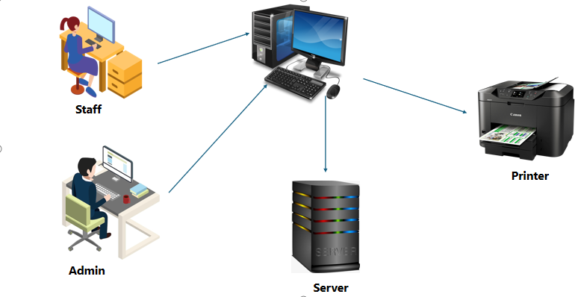
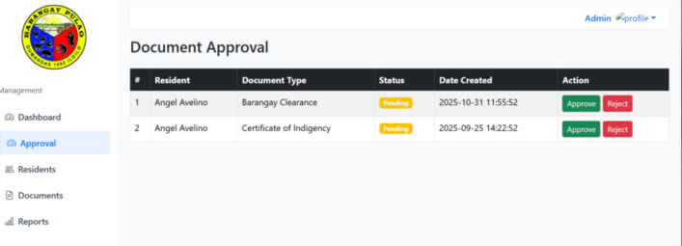

Respondents
The respondents for this capstone project included ten (10) local residents such as barangay captain, barangay secretary and other staff, members who handle administrator tasks and community services. Their inputs for crucial for understanding the current processes and system requirements. Barangay resident community members who will use the system to access service request documents, and communicate with officials. Barangay health workers and service provider individuals involved in delivering health and social services at the barangay level, who can provide insights on how the system can support their work. IT Personnel or System Administrators those responsible for maintaining and supporting the system, to provide technical perspective on system design and implementation.

Data Gathering and Procedures
Data gathering procedures for Automated Barangay information system, structured questionnaires will be distributed to barangay officials and residents to collect quantitative data on their current experiences, needs, and expectations regarding barangay information management. Semi-structured interviews will be conducted with key barangay officials and staff to gain deeper insights into existing processes, challenges, and specific system requirements. Obtain necessary approvals from barangay officials to conduct data gathering activities and schedule interviews and observations.
Interview
involves conducting structured conversations with barangay officials and staff to gather detailed information about the current manual processes, challenges faced, and specific requirements for the new system, ensuring that the developed solution effectively addresses the needs of both the barangay administration and its residents.
Questionnaires
Is designed to gather information from barangay officials and residents regarding their experiences, needs, and expectations for the Automated Barangay Information System.
Permission and Coordination
For the development and implementation of the Automated Barangay Information System will be secured by formally requesting approval from the barangay officials, ensuring their support and collaboration throughout the project, and scheduling meetings to align project activities with the Barangays operational schedules and requirements.
Documentation Review
A comprehensive review of documents, including learning materials used in disseminating information, was conducted to examine current practices and identify areas for

improvement in managing concerns in Dumangas, Iloilo. The review focused on how barangay Pulao. particularly in conducting manual odor checks, using available equipment, and reporting odor-related complaints Findings from this review highlight the fragmented and often manual nature of current practices, underscoring the need for a more streamlined and efficient approach. These insights support the potential development or enhancement of an Automated Barangay Information System (ABIS) that could centralize data collection, enable real-time monitoring, and improve the reporting and response mechanisms within the community.

The review examined the accessibility, effectiveness, and limitations of these current practices, aiming to find ways to improve a Automated Barangay information Sytem
Key areas for improvement included:
· Adding real-time barangay monitoring,
· Providing instant alerts for quick action,
· Making the system easier to user friendly, and
. The insights gathered from this review were essential

in shaping the development of the Automated Barangay Information System. By addressing the gaps in current methods, the system aims to offer a more effective solution to Automated Barangay Information System, benefiting both barangay and nearby residents.

Organizational Chart
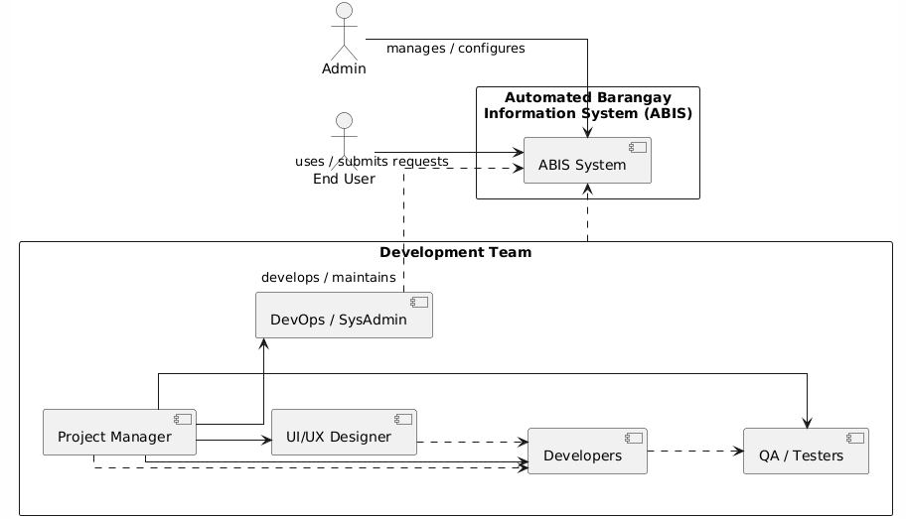
Figure 2. Organizational Chart
Figure 2 illustrates the organizational structure of the Automated Barangay Information System . It shows how the Admin manages and configures the system, while the End User uses the system to submit requests and access services. The Development Team is responsible for designing, developing, and maintaining the system. It consists of a Project Manager who oversees the project and coordinates tasks, a UI/UX Designer who focuses on user interface and experience, Developers who implement system functionalities, a DevOps/SysAdmin who manages deployment and maintenance, and QA/Testers who ensure the system’s quality and performance. The diagram highlights the interaction among these roles to ensure the smooth and efficient operation of the ABIS.
Work Flow of the System
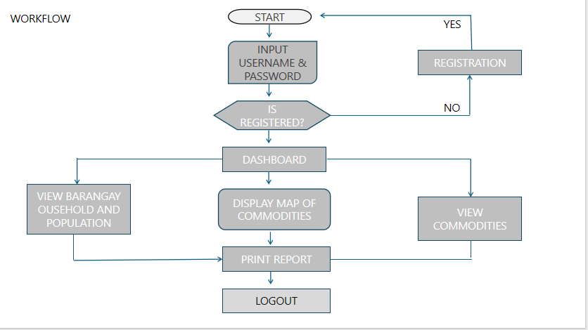

The workflow begins at the Start point. The user is first prompted to input their username and password. The system then checks whether the user is already registered. If the user is not registered, the process directs them to the Registration module, where they can create an account. After completing the registration, they return to the login step.
If the user is registered, the system grants access to the Dashboard. From the dashboard, the user may choose among several available functions. One option is to view the barangay household and population data. Another option allows the user to view the list of commodities, while a central feature of the system displays a map showing the distribution of commodities.
After reviewing any of these modules, the user may proceed to print a report generated from the selected information. Finally, the workflow concludes when the user selects Logout, ending the session.

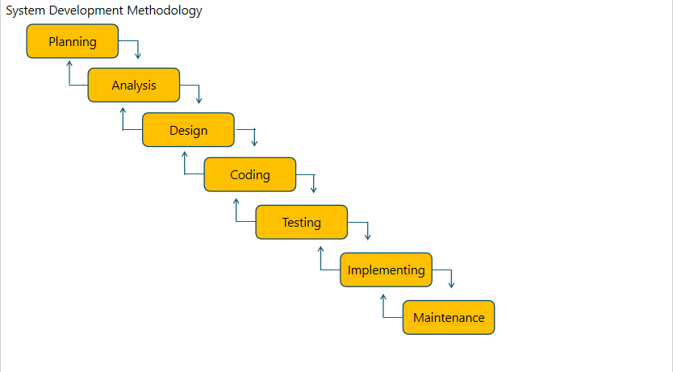
System Development Methodology

Figure 11. Planning Model of ABIS
Figure 11 illustrates the Planning Model utilized in developing the Automated Barangay Information System (ABIS). This model emphasizes a systematic and step-by-step approach in understanding project requirements, identifying needed resources, and defining the overall direction of system development. The Planning Model ensures that each phase—planning, analysis, design, coding, testing, implementation, and maintenance—is carefully considered to meet the operational needs of the barangay.
In the context of this study, the Planning Model guides the formulation of the ABIS by outlining the essential processes needed to create a functional and reliable information system for the barangay. During the planning phase, the objectives of the system are defined, focusing on improving record management, resident profiling, population monitoring, and commodity tracking. The analysis phase follows, identifying existing problems in manual processes and determining user requirements based on consultations with barangay officials and staff.
Project Development Process
This project development process for the Automated Barangay Information System (ABIS) follows a systematic sequence of phases designed to ensure that the system is effectively planned, designed, implemented, and maintained.
1.Planning
This initial phase involves identifying the project’s goals, scope, and feasibility. The development team gathers requirements by consulting with barangay officials to understand the current manual processes and challenges. The primary objectives and resources needed for the project are outlined, and a schedule is created to guide the development timeline.
2. Analysis
In this phase, detailed information about user needs and system requirements is collected and analyzed. The team examines how data is currently managed and identifies key functionalities that the ABIS must include, such as resident profiling, household population tracking, commodity management, and report generation.

3. Design
Based on the analysis, the system’s architecture, user interface, database structure, and workflow are designed. Mock-ups and prototypes of the system interface are created to visualize how users will interact with the ABIS. This phase ensures that the system’s layout is user-friendly and meets the technical requirements.
4. Coding
During coding, the system is developed by translating the design specifications into actual code. Programmers build the system modules, such as user authentication, dashboard, data input, and reporting tools. This phase involves writing clean, efficient code that supports system functionality.
5. Testing

Once coding is completed, the system undergoes rigorous testing to identify and fix any bugs or errors. Functional tests ensure all features operate as intended, while usability tests confirm the system is easy for barangay officials to use. Feedback from test users is incorporated to refine the system further.
6. Implementation
After successful testing, the system is deployed for actual use in the barangay. Training sessions are conducted to familiarize users with the ABIS, ensuring a smooth transition from manual to automated processes.
7. Maintenance
Following implementation, the system enters the maintenance phase, where it is continuously monitored, updated, and improved. Any technical issues are resolved promptly, and enhancements are made based on user feedback to keep the system efficient and relevant.

Requirements Analysis
A critical phase in the development of the Automated Barangay Information System (ABIS). During this phase, the project team gathers, evaluates, and documents the functional and non-functional requirements necessary to design a system that effectively meets the needs of the barangay and its stakeholders.
PIECES Evaluation Framework
The PIECES evaluation framework was applied to identify the key problems and areas for improvement addressed by the Automated Barangay Information System. This includes an assessment of performance, information, economy, control, efficiency, and service aspects relevant to improving environmental monitoring in barangays.

Table 1. The PIECES Evaluation Framework
Performance | automated Barangay Information provides real-time monitoring of record of barangay action, ensuring immediate monitoring and timely alerts for abnormal environmental conditions.
Information | The system delivers accurate and up-to-date information on barangay, which supports evidence-based decision-making for information management.
Economy | Automated barangay information System is designed using low-cost components such as ESP32 microcontrollers and MQ-135 sensors, making it affordable for small- to medium-scale Barangay information operations.
Control | The system features a user-friendly dashboard and alert system, allowing users to easily monitor local barangay information and receive notifications via email or web, thereby improving responsiveness.
Efficiency | By automating the barangay information process, Automated barangay information system manual inspection efforts and enables quicker response to environmental issues, increasing overall barangay operational efficiency.
Service | The system provides an essential service by promoting barangay information process, environments, protecting community registration/records, and supporting sustainable barangay information practices.

Cause and Effect Analysis

Table 2. Cause and effect Analysis of the Study
Problem | Cause & Effect | Solution
People (Human Factors) | Lack of training for barangay officials  Low digital literacy among residents  Resistance to shift from manual to automated processes  Insufficient technical support staff | Conduct regular training sessions for barangay officials and staff on how to use ABIS.  Develop user-friendly guides (manuals, videos) for residents.  Assign dedicated IT support staff at the barangay or municipal level.  Promote community awareness campaigns to encourage trust and adoption of the system.
Process (Workflows & Procedures) | Unclear approval procedures for permits/clearances  Inconsistent complaint handling process  No standardized data entry guidelines  Delayed response times | Standardize workflows for common services (permits, certificates, complaints).  Create a clear approval hierarchy in the system to avoid confusion.  Implement automated reminders and notifications to reduce delays.  Develop a feedback mechanism so residents can track their requests and complaints.
Technology (System & Infrastructure) | Slow or unstable internet connection  Outdated or insufficient hardware (computers, servers)  System downtime due to poor maintenance  Weak cybersecurity protection | Upgrade barangay ICT facilities (computers, servers, reliable internet).  Implement cloud-based hosting for better uptime and scalability.  Establish a maintenance schedule for the system.  Strengthen cybersecurity measures (firewalls, encryption, multi-factor authentication).
Data / Information | Incomplete or outdated resident records  Incomplete or outdated resident records  Errors in data entry during system migration  No regular backup or recovery plan  Lack of data integration with other LGU systems  5. Environment (External Factors) | Conduct data cleansing and validation before migrating records.  Establish a regular update schedule for resident information.  Implement automated backup systems to prevent data loss.  Integrate ABIS with LGU and national government databases for consistency.·
Environment (External Factors) | Provide backup power sources (e.g., generators, UPS) to reduce downtime during outages.  Allocate sufficient budget for ICT and system maintenance.  Build community trust by demonstrating transparency (residents can view status updates online).  Collaborate with stakeholders (e.g., farm operators for air quality monitoring) to ensure compliance and cooperation. | Provide backup power sources (e.g., generators, UPS) to reduce downtime during outages.  Allocate sufficient budget for ICT and system maintenance.  Build community trust by demonstrating transparency (residents can view status updates online).  Collaborate with stakeholders (e.g., farm operators for air quality monitoring) to ensure compliance and cooperation.

Developmental Cost
Table 3 shows the actual expenses of the researchers in the development of the study.
Table 3. System Cost

Particulars | Quantity | Rate/Unit Cost | Total
Computer Usage | 2 months | ₱50.00 | ₱100.00
Internet | 2 months | ₱100.00 | ₱600.00
Transportation | 2 months | ₱150.00 | ₱600.00
Supplies:  Bond paper  Ink | 5 reams  1 set | ₱5.00/pc weeks  ₱300.00/pc | ₱30.00  ₱600.00
Other  Cellphone Load  Food | 2 months  1 visit | ₱500.00/month  ₱300.00/visit | ₱500.00  ₱300.00
Total Development Cost |  |  | ₱2,730.00

Gantt Chart
This section explains the phases undertaken in the
development of the project. The developers were able organize the schedules needed to complete the entire system
development process.

Requirements Documentation

Requirement’s documentation is a process wherein the requirements for developing an Automated Barangay Information System (ABIS). ABIS aims to digitize barangay operations in the Philippines, improving efficiency in resident management, service delivery, and reporting.

Requirements and Constraints

To ensure the successful implementation and user acceptance of the Automated Barangay Information System (ABIS), the system must meet specific functional requirements and operate within defined constraints.

The system must be capable of the following:

- Storing and Managing Resident Information
- Generating Barangay Documents Automatically
- Monitoring and Recording Daily Barangay Activities
- Transmitting Data to a Centralized Database
- Displaying Updated Barangay Data Through a User Interface
- Operating with Minimal Technical Resources
- Providing a User-Friendly and Low-Maintenance Platform

Constraints
The system design must conform to the following limitations:

- The system must operate on standard barangay office computers, which may have low processing power, limited storage, and outdated operating systems.

- Since many barangays may not have reliable internet access, the system must function offline or with intermittent connectivity, syncing only when a connection is available.

- System development, deployment, and maintenance must fit within the Barangays limited financial resources, minimizing the need for costly equipment, servers, or subscriptions.

- Barangay staff may have varying levels of computer literacy, so the system must remain easy to understand and navigate to prevent misuse or data entry errors.

- Barangay offices often have minimal space, so the system must require only essential equipment and avoid complex setups.

Functional Requirements

The Automated Barangay Information System (ABIS) provides a centralized platform for managing resident information, barangay records, and administrative transactions. It enables barangay officials and staff to streamline operations, improve service delivery, and access important data efficiently.
To ensure the system is effective and user-friendly, the following functional requirements are in place:

Resident Information Management:The system must allow users to add, update, delete, and search resident profiles, including demographic and household details.

Automated Barangay Document Generation: The system must generate commonly requested documents such as Certificates of Residency, Indigency, Barangay Clearance, and other official records.

Real-Time Monitoring of Barangay Transactions and Records: Users must be able to monitor document requests, issued certificates, blotter records, and other barangay activities in real-time via a dashboard.

Accessible and User-Friendly Interface:The system must provide a simple, intuitive interface that allows barangay officials and staff to navigate records and perform tasks efficiently.
reporting and Data Analytic: The system must generate automated reports such as population summaries, household statistics, blotter reports, and document issuance logs.
Design Specification
Non-Functional Requirements
The Automated Barangay Information System (ABIS) is a digital platform designed to give barangay officials and staff real-time access to resident records, document transactions, and administrative data. The system ensures that users can quickly view and process information such as resident profiles, blotter reports, certificate issuances, and barangay statistics. The application offers an intuitive interface for managing barangay operations while maintaining consistency, accuracy, and security across multiple devices used within the barangay office.
These non-functional requirements ensure scalability, reliability, and efficient processing of barangay records and services.

Hardware Requirements
Table 4. Hardware Specification
Table 5. Software Specification

Hierarchical Input-Process-Output
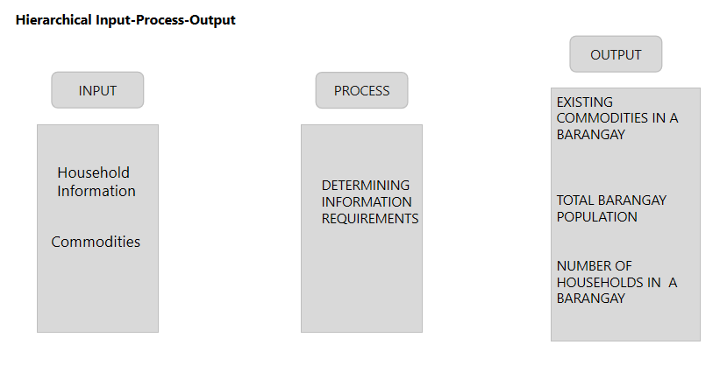
Figure 13. Hierarchical Input-Process-Output
Figure 13 illustrates the hierarchical structure and functionality of the Automated Barangay Information System interface. The simplified system shown in the diagram depicts a user interacting with the interface to provide data and commands. The primary input includes household information and commodities available in the barangay. After processing these inputs by determining information requirements, the system executes operations and generates outputs such as the list of existing commodities in the barangay, the total barangay population, and the number of households. To complete certain tasks, the system may also communicate with other modules or external devices, such as a local server or cloud database. By identifying the inputs, processes, and outputs for each module, the HIPO (Hierarchy plus Input-Process-Output) analysis breaks the system into manageable modules. This hierarchical approach makes the system’s structure and operation easier to understand while facilitating efficient analysis, design, and maintenance.

Use Case Diagram
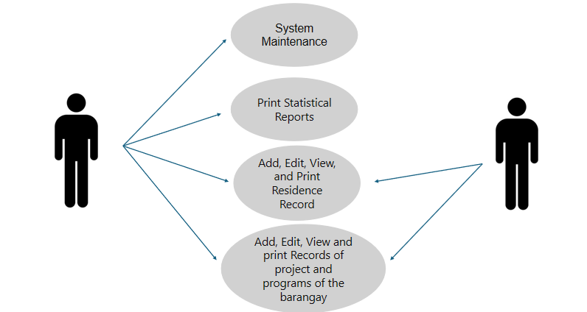
Diagram and Figure 14. Use Case Diagram of ABIS
Figure 14 illustrates the Use Case Diagram of the Automated Barangay Information System (ABIS), presenting how the system’s main actors interact with its core functionalities. The diagram shows two users representing the Barangay Staff and the Barangay Administrator, each performing different operations within the system.
The use cases include System Maintenance, Print Statistical Reports, Add, Edit, View, and Print Residence Records, and Add, Edit, View, and Print Records of Barangay Projects and

Programs. These functions demonstrate how users initiate actions, supply input, and trigger system processes depending on their assigned roles. The Barangay Administrator has full access privileges, including system maintenance, while the Barangay Staff handles routine tasks such as report generation and records management.

By identifying the specific interactions between actors and system functions, the Use Case Diagram provides a clear understanding of how ABIS supports barangay operations and ensures accurate and efficient information management across its modules.

Sequence Diagram
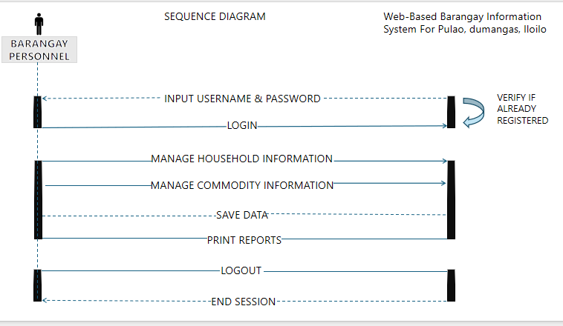
Figure 15. Sequence Diagram of ABIS
Sequence Diagram (Figure 15) illustrates the chronological interactions for a Barangay Personnel utilizing the Automated Barangay Information System (ABIS). The process begins with the Personnel sending their credentials and initiating a login, which prompts the system to internally VERIFY their registration. Once authenticated, the Personnel gains access to the core data management functions, specifically sending messages to manage household information and manage commodity information. Following any data changes, the Personnel sends a SAVE DATA command to ensure information persistence, and can also request to print reports. Finally, the session is securely concluded when the Personnel sends the logout message, leading the system to perform an end session. This step-by-step flow, visualized by messages and activation bars, precisely maps out the operational sequence from system access to exit for this user role.

Activity Diagram
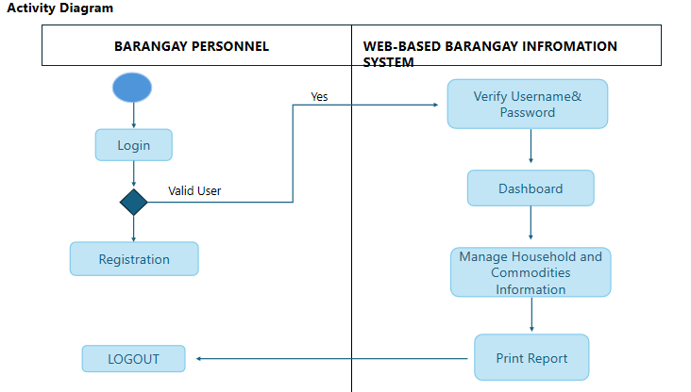
Figure 16. Activity Diagram of ABIS
The Activity Diagram (Figure 16), which illustrates the workflow for the Web-Based Barangay Information System (ABIS), is divided into two swim-lanes: Barangay Personnel and the Web-Based Barangay Information System.

The process begins with the Barangay Personnel attempting to Login. A decision point, Valid User, determines the flow. If the user is a valid user ("Yes"), control is passed to the system, which then Verify Username & Password. The system proceeds to display the Dashboard, allowing the personnel to Manage Household and Commodities Information. Following data management, the system generates a Print Report, after which control returns to the personnel. Regardless of the login outcome, the personnel's sequential steps in this specific flow include Registration and ultimately LOGOUT, which concludes the illustrated activity.

Deployment Diagram
Figure 17. Deployment Diagram of ABIS
The Deployment Diagram (Figure 17) for the Web-Based Barangay Information System (ABIS) illustrates the physical architecture and network topology, centering on a three-tier client-server structure. The system's operation revolves around a central Computer that serves as the workstation for both the Staff and the Admin, who connect to it to perform their tasks. This Computer is essential to the system's function as it is networked to the Server, which hosts the core application logic and data, allowing for processing and storage of information. Finally, the Computer is also connected to a Printer, which facilitates the generation of hardcopy reports and documents from the system, completing the physical workflow required by the Barangay Personnel.

CHAPTER IV
PRESENTATION, ANALYSIS, AND INTERPRETATION OF DATA

